**BIKE THEFT DETECTION SYSTEM**

**A PROJECT REPORT**

***Submitted by***

|  |  |
| --- | --- |
| **DIWAKAR N** | **(Reg. No. 201304029)** |
| **KARTHIKEYAN R R** | **(Reg. No. 201304055)** |
| **MADHU PERKIN T** | **(Reg. No. 201304059)** |

***in partial fulfillment for the award of the degree***

***of***

**BACHELOR OF ENGINEERING**

**in**

COMPUTER SCIENCE AND ENGINEERING

**DEPARTMENT OF COMPUTER SCIENCE AND ENGINEERING**

**MEPCO SCHLENK ENGINEERING COLLEGE, SIVAKASI**

**(An Autonomous Institution affiliated to Anna University Chennai)**

**April 2017**

**BONAFIDE CERTIFICATE**

Certified that this project report titled **BIKE THEFT DETECTION SYSTEM** is the bonafide work of **Mr. DIWAKAR.N, Mr. KARTHIKEYAN.R.R, Mr. MADHU PERKIN .T** who carried out the research under my supervision. Certified further, that to the best of my knowledge the work reported herein does not form part of any other project report or dissertation on the basis of which a degree or award was conferred on an earlier occasion on this or any other candidate.

Mrs. M. Nagajothi, M.E., Dr. K.Muneeswaran, M.E., Ph.D.,

**Internal guide Head of the Department**

**Assistant professor (Sr. Grade), Senior Professor,**

**Department of Computer Science Department of Computer Science and Engineering, and Engineering,**

**Mepco Schlenk Engineering College, Mepco Schlenk Engineering College,**

**Sivakasi. Sivakasi.**

Submitted for viva-voce Examination held at **MEPCO SCHLENK ENGINEERING COLLEGE, SIVAKASI (AUTONOMOUS)** on **……………..............**

**Internal Examiner External Examiner**

|  |  |  |  |
| --- | --- | --- | --- |
| **ACKNOWLEDGEMENT**  **ACKNOWLEDGEMENT**    First and foremost, we thank the Almighty for his abundant blessings that is showered upon our past, present, future successful endeavors.  At the appellation, we would like to extend our sincere gratitude to our reverent principal, **Dr. S. Arivazhagan, M.E., Ph.D.,** for providing sufficient working environment such as system and library facilities. We also thank him very much for providing us with adequate lab facilities, which enable us to complete our project.  We are grateful to our charismatic Head of the Computer Science Engineering and Department **Dr. K. Muneeswaran, M.E., Ph.D.,** for giving us this golden opportunity to undertake a project of this nature and for his most valuable guidance given at every phase of our work.  We would also like to extend our gratitude **Mr. C. Bala Subramanian, M.Tech., (Ph.D)** Assistant professor (Sr. Grade), Department of Computer Science and Engineering, Mepco Schlenk Engineering College for being our project coordinator and directing us through our project.  We thank **Mrs. M. Nagajothi, M.E.,** Assistant professor, Department of Computer Science and Engineering, Mepco Schlenk Engineering College for her valuable guidance and encouragement.  We acknowledge with the sense of gratitude, the help given to us by all the staffs and technicians in the department.  We are very grateful to our beloved parents and friends who afforded the necessary help for us at the right time for making our project a grand success.    **TABLE OF CONTENTS**  **TABLE OF CONTENTS** | | | |
| **CONTENTS** | |  | **PAGE NO** |
|  | |  |  |
| **ABSTRACT** | |  | Iii |
| **LIST OF FIGURES** | |  | Vii |
| **LIST OF TABLES** | |  | Viii |
| **LIST OF ABBREVIATIONS** | |  | Ix |
| **CHAPTER 1** | | **INTRODUCTION** |  |
|  | |  |  |
|  | 1.1 | GENERAL | 1 |
|  | 1.2 | OBJECTIVE OF THE PROJECT | 4 |
|  | 1.3 | PROBLEM STATEMENT | 4 |
|  | 1.4 | PROPOSED SYSTEM | 5 |
|  | 1.5 | APPLICABLE AREAS | 5 |
| **CHAPTER 2** |  | **LITERATURE SURVEY** |  |
|  | 2.1 | AFFINITY ANALYSIS AND ASSOCIATION RULE MINING USING APRIORI ALGORITHM IN MARKET BASKET ANALYSIS | 6 |
|  | 2.2 | DATA MINING BASED STORE LAYOUT ARCHITECTURE FOR SUPERMARKET | 17 |
|  | 2.3 | INFORMATION SYSTEM ON MARKET BASKET ANALYSIS | 20 |
|  | 2.4 | ALIGNMENT AND INTEGRATION OF COMPLEX NETWORKS BY HYPERGRAPH- BASED SPECTRAL CLUSTERING | 22 |
| **CHAPTER 3** | | **SYSTEM DESIGN** |  |
|  | 3.1 | DATA FLOW DESIGN | 37 |
|  |  | 3.3.1 Transaction REPOSITORY |  |
|  |  | 3.3.2 fILTER SINGLE ITEM ORDER |  |
|  |  | 3.3.3 FREQUENT ITEM SET MINING |  |
|  |  | 3.3.4 HYPER GRAPH CONSTRUCTION |  |
|  |  | 3.3.5 HYPER GRAPH CLUSTERING |  |
| **CHAPTER 4** | | **SYSTEM IMPLEMENTATION** |  |
|  |  |  |  |
|  | 4.1 | FILTER SINGLE ITEM ORDER IMPLEMENTATION |  |
|  | 4.2 | FREQUENT ITEM SET MINING IMPLEMENTATION |  |
|  | 4.3 | HYPER GRAPH CONSTRUCTION |  |
|  | 4.4 | HYPER GRAPH CLUSTERING IMPLEMENTATION |  |
| **CHAPTER 5** | | **RESULTS AND DISCUSSION** |  |
|  |  |  |  |
|  | 5.1 | TEST CASES AND RESULTS |  |
|  |  | 5.1.1 INPUT DATA |  |
|  |  | 5.1.2 FILTER SINGLE ITEM ORDER TESTING AND RESULTS |  |
|  |  | 5.1.3 FREQUENT ITEM SET MINING TESTING AND RESULTs |  |
|  |  | 5.1.4 HYPER GRAPH CONSTRUCTION TESTING AND RESULTS |  |
|  |  | 5.1.5 HYPER GRAPH CLUSTERING TESTING AND RESULTS |  |
|  |  | 5.1.6 NAMING THE PRODUCT ID |  |
|  |  | 5.1.7 representation of clusters |  |
|  |  | 5.1.8 Positive predictive value (ppv) |  |
| **CHAPTER 6** | | **conclusion and future enhancement** |  |
|  |  |  |  |
| **APPENDIX A**  **APPENDIX B**  **APPENDIX C** |  |  | 55 |
|  |  |  |  |

**ABSTRACT**

**ABSTRACT**

In today’s era everyone is using motor bikes for transportation. Bike theft started increasing now a days. In an attempt to prevent this, we propose a GPS and GSM based bike tracking and controlling system to help the users locate their bikes using GPS. The proposed technology allows people to get alert and can track real-time information about their bike when stolen. The system is equipped with GPS and GSM modules along with Arduino microcontroller and relay that is installed in bikes. The integration of the system with the bike is also simple without any major modifications to the bike design. During bike theft or when a bike is started without key, user receives an alert message from the system installed on bike and the bike is controlled based on the reply message received from the owner. This location information will be sent to registered mobile number. The request to the tracking system can be made through SMS from a registered mobile number or through website after authentication and the bike can be stopped based on the user’s command. It is completely integrated in bikes making it easy to track them any time. The user is also provided service from the nearest service centre through our website automatically.

**LIST OF FIGURES**

**LIST OF FIGURES**

**S. No. FIGURE No. FIGURE NAME PAGE No.**

1. 3.1 Data Flow Design of Market Basket Analysis 6

2. 3.2 Construction of FP Tree from the transaction 13

3. 3.3 Representation of Hyper Graph 14

4. 5.1 Transaction of data 15

5. 5.2 Product ID and its corresponding name 17

6. 5.3 Frequent pattern tree 35

7. 5.4 FP Growth tree 36

8. 5.5 Hyper Graph edges 37

9. 5.6 Hyper Graph clustering 38

10. 5.7 Naming with product id 39

11. 5.8 Representation of clusters 40

12. 5.9 PPV vs number of items 41

13. 5.10 PPV vs number of transactions 42

**LIST OF TABLES**

**LIST OF TABLES**

**S. No. TABLE No. TABLE NAME PAGE No.**

1. 5.1 Test Case for Filter Single Item Order 12
2. 5.2 Test Case for Frequent Item Set Mining 22
3. 5.3 Test Case for Hyper Graph Construction 24
4. 5.4 Test Case for Hyper Graph Clustering 25
5. 5.5 Test Case for Name the Product ID 26
6. 5.6 Representation of Clusters 29

**LIST OF ABBREVIATIONS**

**ABBREVIATION**

MBA : Market Basket Analysis

FISM: Frequent Item Set Mining

FIS : Frequent Item Set

FP : Frequent Pattern

PPV : Positive Predictive Value

KDD : Knowledge Discovery in Database

**INTRODUCTION**

**CHAPTER 1**

**1 INTRODUCTION**

This chapter is about the general description of the proposed system, objectives of the proposed system, outcome of the proposed system and then the organization of the report.

* 1. **GENERAL:**

Nowadays use of two-wheelers has increased over-time. They were used for moving from one place to other for example: people who are working has to move from their home to their work-place and have to park their vehicles in the available places and also the theft has increased over the time. It will be easier for thief to rob the bike by either sparking or fusing the wire beneath the key or else by throwing the bike over a vehicle carrier or van. There are several ways of making the theft of bike.

In this respect we have developed a Bike theft detection system which aims to reduce the theft of bike by a major percentage. Our system aims to provide security with the combination of GPS and GSM along with Relay circuit. First of all, user will be able to track the location of vehicle by sending ‘Track location’ message and turn the vehicle off by sending ‘Off’ message. Also the user will be able to view the nearest service center location through our website.

All these can be directly coordinated either by mobile SMS or through the web portal after authentication. The project aims to maximize the focus with the detection of bike theft and controlling the bike even from any remote place and able to find the navigation coordinates of the bike. With the help of this we would be able to make criminal investigation with the help of the police. The whole system kit will be placed between the petrol tank and the engine. So it will be slightly difficult for the thief to break the security system because the bike will be rendered useless by making it unusable by the thief. Also the system is issued to the customer at a very low Cost.

1. **OBJECTIVES:**

* To identify the vehicle’s location and control it from the remote location.
* To reduce theft and increase security.
* To identify the nearest vehicle service center.
* To easily identify the lost vehicle.

1. **PROBLEM STATEMENT:**
   * During vehicle theft especially car there is a way for finding their location precisely which is also possible only in high-end cars.
   * But the vehicle theft also includes bike where is no anti-theft detection system as found in high-end cars.
   * If the same features were included in the bike, then it could be secured from theft.
   * □ enable these features we have developed this bike theft detection system and have implemented this.
   * Also this project aims to provide the solution at a very low cost.
2. **PROPOSED SYSTEM:**
   * It is important to automate the bike theft detection process to reduce theft.
   * Uses GSM technology for sending and receiving messages which is considered as reliable communication network.
   * It will be easy for user to send and receive messages through either mobile phones or web portal after authentication. Also the SMS like ‘Engine off’, ‘Track’ is used to turn off the engine and track location respectively.
   1. **ORGANIZATION OF REPORT:**

The overviews of the subjects described in the underlying chapters are given below.

* **Chapter 2:** Covers discussion about the related works carried out beforeformulating the proposed system. It also briefs about the methods adopted by existing system and its disadvantages
* **Chapter 3:** Deals with the overview design of the proposed system and theformulations used in the implementation of the system.
* **Chapter 4:** Outlines the design and explains the methodology of the proposedsystem.
* **Chapter 5:** Deals with the implementation of the proposed system, how themodules interact and how the method executes to come with the required result.
* **Chapter 6:** Explains about the experiments carried out in proving the efficiency ofthe system.
* **Chapter 7:** Concludes about the system and discusses about any futureenhancements.

**LITERATURE SURVEY**

**CHAPTER 2**

**2 LITERATURE SURVEY**

There are several ways of tracking and controlling bike with some other technologies used. The proposed system was developed on behalf of the existing system. Some of the earlier works are discussed below.

**2.1 DESIGN & DEVELOPMENT OF A GSM BASED VEHICLE THEFT CONTROL SYSTEM (2010)**

In recent years, vehicle thefts are increasing at an alarming rate around the world. People have started to use the theft control systems installed in their vehicles. The commercially available anti-theft vehicular systems are very expensive. Here, we make a modest attempt to design & develop a simple, low cost vehicle theft control scheme using an inbuilt microcontroller. This scheme involves a microcontroller & a mobile for the communication purposes.

Control functions of the tracking system allow us to perform many function such as to lock & unlock the doors, engine stopping & starting, automatic position reporting based on time or distance, over speed detection & reporting, remote start output on tracking device, etc.

The system consists of combination of has a GSM mobile, Microcontroller, Relay, Keypad, LCD, Power supply blocks which interact with each other as follows: When switched on, the power supply supplies 5V to microcontroller for its operation and 12V to relay which is assumed to come from the battery of the vehicle to the key assembly. When the vehicle is stolen, a ring is made to the secret number by authorized person, then mobile gives high signal from its ringer circuit to the micro-controller, then the microcontroller disconnects the connection from the relay which is 12V, until the person comes to the spot and enters the specified password the vehicle will not start. If there is an error, error message is displayed on LCD for convenience. If the entered password is correct, then normal operation will proceed.

Microcontroller is the heart of the designed unit, which handles all the signals. The power supply consists of AC voltage transformer, diode rectifier, ripple filter and voltage regulator. The relay we are using in this work is a 230V / 2A relay and it’s an electromechanical relay. Keypad is used for validating the input. LCD will be used to display the message both error/accepted. The designed unit employs a system that uses information available to the cell phone operators as a matter of course to determine location of any mobile phones within the GSM network. A novel method of designing a low-cost, compact theft control system for a vehicle was designed & demonstrated in this paper. This work is an ultimate threat for vehicle thieves.

**MERITS:**

* The entire designed unit is on a single chip
* The designed unit is very simple & low cost.

**DEMERITS:**

* Vehicle’s location can’t be determined.
  1. **INTELLIGENT ANTI-THEFT AND TRACKING SYSTEM FOR AUTOMOBILES (2011)**

The proposed security system in this paper is designed to track and monitor vehicles that are used by certain party for particular purposes, also to stop the vehicle if stolen and to track it online for retrieval, this system is an integration of several modern embedded and communication technologies.

The system has two main units; the first is security unit which is embedded in the vehicle. This unit consists of: a GSM modem, GPS receiver, control relay, current sensor and Microcontroller. The current sensor will send an analog signal to the microcontroller when the car is running. The microcontroller will send SMS directly to the owner to confirm that. The Microcontroller processes the GPS information and transmits it to the user using GSM modem by SMS every 10 minutes when the user asked that from the system by sending SMS contains code.

A Kalman filter is used to correct factors influencing the accuracy of position determination include: satellite geometry, shifts in the satellite orbits, clock errors of the satellite’s clocks, tropospheric and ionospheric effects and calculation errors.

The first received input is the GPS output, which has a sentence based on NMEA 0183 standard. The second input is obtained by the vehicle data port, typically called ON Board Diagnostics port, version II (OBD-II). The unit sends an SMS using Hayes command (AT Command). The third is analog signal from the current sensor when the vehicle is running. In our tracking system we used Google Earth software for tracking and viewing the status of the vehicle. Google Earth currently supports most GPS devices. The application included a transmitting module which contains an embedded system to combine GPS and GSM devices to retrieve location and vehicle status information and send it to the other stationary module; the second part is the receiving module which collects the transmitted information by SMS and process it to a compatible format to Google Earth to view the location and vehicle status online.

**MERITS:**

* Accurate location is identified.
* The user can turn off his/her vehicle of the fleet if any intruders try to run it by

**DEMERITS:**

* It Needs High power.
* Always the system is ON.
  1. **A SMART ANTI-THEFT SYSTEM FOR VEHICLE SECURITY(2012)**

Vehicle focal locking framework guarantees the best ensure to secure your vehicle from various types of burglary cases. It is a vehicle security gadget that offers fantastic insurance to your vehicle. However, this framework couldn't demonstrate to give complete security and openness to the vehicle in the event of burglary. So a more created framework makes utilization of an inserted framework focused around GSM innovation. The outlined and created framework is introduced in the vehicle. Whether one is holder of single vehicle or in excess of 1000, Vehicle Tracking System (VTS) is an answer for spot, track and secure your portable resources.

The utilization of ARM 7 microcontroller, GSM and GPS module together with an accelerometer and temperature sensor is carried out by Joshi and Mahajan. The GPS and GSM module is being utilized for following the area of vehicle.

A smart anti-theft vehicle security system consists of GSM module, GPS module, 8051 microcontrollers, infrared sensors, DTMF decoder IC MT8870DE, relay, paint spray and high voltage mesh. The hardware design is split into two parts- GSM and GPS. Whenever someone attempts to unlock the vehicle, the security components installed in the vehicle sends a signal to the owner of the vehicle via GSM modem or GSM mobile. The owner then tries to establish connectivity with the security system in the vehicle through calling a predefined number. Once the connectivity is established, the owner can choose one of the four actions like engine ignition cut-off, fuel supply cut-off, windscreen paint system and electric shock system as per his judgment in order to prevent the vehicle from theft.

The Global Positioning System (GPS) is a space-based satellite route framework that gives area and time data in all climate conditions, anyplace on or close to the Earth where there is an unhampered observable pathway to four or more GPS satellites. The framework gives basic abilities to military, common and business clients as far and wide as possible. It is kept up by the United States government and is uninhibitedly open to anybody with a GPS receiver.

Tracking framework or system is getting to be progressively vital in expansive urban areas and it is more secured than different frameworks. It has continuous ability, rises with a specific end goal to fortify the relations among individuals, vehicle and street by assembling present day data advances or technologies and ready to structures a real time accurate, compelling exhaustive transportation framework. Updating this setup is simple which makes it open to future a prerequisite which likewise makes it more efficient.

**MERITS:**

* In case of accident this system automatically sends the message for help to one’s relatives.
* The designed unit is very simple & low cost.

**DEMERITS:**

* This system is not applicable for motor bikes, though it is installed it in not cost effective.
  1. **NEXT GENERATION AUTO THEFT PREVENTION AND TRACKING SYSTEM FOR LAND VEHICLES ( 2013)**

The project proposed here aims to design a next generation auto theft prevention system by adding significant enhancements and modernizing the existing system and thus try to overcome the above drawbacks. By implementing this techniques, the possibility of a car Theft is very less or no theft. The following modules are implemented in this project. First a new Innovative car key is designed, the car key transfers a random data by providing the air gesture each and every time the car is unlocked. The transaction of password from key to car is known only to these devices and any intermittent unit cannot diagnose the transaction as each and every time the data is changing. The cryptographic technique is used which provides encrypted data transmission and reception. A dual layer keying approach is followed during vehicle ignition process.

The protocol provides reliable direct wireless communication via an easy-to-use programming interface. The MiWi P2P protocol is a variation of IEEE 802.15.4 and supports both peer-to-peer and star topologies. It has no routing mechanism, so the wireless communication coverage is defined by the radio range. The MiWi P2P stack uses only a portion of the IEEE 802.15.4 specification’s rich PHY and MAC layers’ definitions. The MRF24J40 radio operates on the 2.4 GHz, ISM band – freely available worldwide. The total bandwidth for the IEEE 802.15.4, 2.4 GHz ISM band is, theoretically, 250 kbps. In reality, for reliable communication, the bandwidth is 20-30 kbps.

RC4 is a stream cipher, symmetric key algorithm. The same algorithm is used for both encryption and decryption as the data stream is simply XORed with the generated key sequence. The key stream is completely independent of the plaintext used. It uses a variable length key from 1 to 256 bit to initialize a 256-bit state table. The state table is used for subsequent generation of pseudo- random bits and then to generate a pseudo-random stream which is XORed with the plaintext to give the cipher text.

A vehicle security system combines the installation of an electronic device in a vehicle, or fleet of vehicles, with purpose designed computer software at least at one operational base to enable the owner or a third party to track the vehicle’s location, collecting data in the process from the field and deliver it to the base of operation. Modern vehicle tracking systems commonly use GPS technology for locating the vehicle, but other types of automatic vehicle location technology such as MEMS accelerometer and magnetometer, adjustable alarming system, fuel cut-off can also be used. GPS fencing notifies the system when a vehicle is equipped with the tracking device crosses a virtual boundary. The notification can be sent to the owner’s cell phone. It usually includes the time, date and location that the virtual boundary was crossed, allowing for an immediate investigation or response to the situation. GPS fencing is suitable for keeping vehicles out of prohibited areas e.g. Sacred Sites, blast zones, environmentally sensitive areas, construction zones. Automatically speed limiting vehicles in designated areas. This feature restricts the vehicle movement within a particular area. This provides more protection to the vehicle even when the key fob is stolen. Secondly a navigation device for land vehicle involves the MEMS accelerometer and magnetometer integrated with the GPS, so during GPS outage the vehicle is navigated using navigation sensor. The adjustable motion alarm is used which helpful to intimate the vehicle owner about the intentional touch given by the thief.

**MERITS:**

* This system prevents unauthorized access of the vehicle to a vast extent.

**DEMERITS:**

* Highly expensive compared to existing system.
* A high Current supply is necessary to ON the system.
  1. **VEHICLE TRACKING SYSTEM USING GPS AND ANDROID OS (2015)**

This system consists of an android mobile which contains GSM and GPS modem along with the processor that is fitted in the vehicle permanently. This device is called as tracking device which is continuously accessing its current location and is sending updates to server.

At monitoring device which is an android application is providing the user with the exact location of the vehicles of his interest. To determine précised location of object Abid khan and Ravi Mishra have proposed tracking unit which it is attached and using GSM modem this information can be transmit to remote user. This system contains GPS and GSM modems along with ARM processor that is setup in the vehicle. Through SMS the location of vehicle can be reported. GSM and GPS technologies helps to track the vehicles exact information. Real time control is provided by SMS system. You can monitor the location from anywhere using this system.

To help individuals in finding addresses and locate their services of interest using their mobile devices Hassan I. Mathkour has propose and develop a GPS-based Mobile Service Locator System. To determine the approximate distances between the user and the locations of the desired place this system was developed. This system is flexible and extendible to easily get the location of the user’s interest places. A main purpose of departure from existing similar systems are that it is the GPS-based rather than the mobile-based service provider to allow for a more accurate location calculation.

Monitoring unit is an Android Application through which user will get to know the actual position of proposed vehicles. This android provides the user interface through which user communicate with system. It provides login to the system. After login to the system user is will get google map with exact location of vehicles.

Monitoring unit, tracking unit and server are the main pillars of GPS based vehicle tracking system. In this system GPRS service is used to perform communication between monitoring and tracking unit to server. Author has used Android platform and Java language for implementation of Monitoring as well as tracking unit. Monitoring side consist of Login page, Signup page and Google Map with the location of required vehicles. As user can easily use this application by sign up and he will get all login rights.

**MERITS:**

* The vehicle’s location can be identified.
* The system allows those companies to monitor the travelled routes through a web client that uses the Google Maps API.

**DEMERITS:**

* Use of android phone is essential.

* 1. **GPS BASED ADVANCED VEHICLE TRACKING AND VEHICLE CONTROL SYSTEM (2016)**

Most of the tracking systems use GPS module to locate the vehicle’s position. Many systems also combine communication components such as satellite transmitters to communicate the vehicle’s location to a remote user. Google maps are used to view the vehicle’s location. The design of the tracking system is divided into three parts; basic design, intermediate design and an advance Design. The basic design of the vehicle tracking system consists of a GSM module, a GPS module, a MCU (ATMEL), a Relay circuit and a LCD. The user sends SMS and the system responds to the user’s request by providing the coordinates of a location in accordance to the requirements of mobile phone users through the GPRS network. The intermediate and advance design is an improvement of the basic design. There are five features introduced in the project. SMS codes are specifically assigned to each of these features. For example, if the user sends ‘555’ to the tracking system. The GSM modem will receive the SMS and transmit to the MCU unit, where the SMS code will be compared against the codes stored in the library.

There are two ways to control an electronic circuit either using: Microprocessor or MCU. The Microprocessors are usually referred to as general-purpose microprocessors because they do not contain RAM, ROM and I/O ports. So, system designers have to add an external RAM, ROM and I/O ports to make a system functional. Addition of these components will make the system bulkier and much more expensive. The advantage of using microprocessor is that the designer can decide the amount of RAM, ROM and I/O ports needed to accomplish a task.

A GSM module is a second generation digital mobile cellular technology, which covers a fairly broad geographic area. This offers customized travel, financial, reference and commercial information to the users [38]. It can operate in 400MHz, 900MHz and 1800MHz frequency bands. The GSM modem can accept a SIM card just like a mobile phone and operate on a subscription to a network of mobile data transfer. The GSM Modem supports three types of services namely bearer or data services, supplementary services, and telecommunication services.

The advance design will allow the user to get the locations of a tracking vehicle without entering any command or sending codes to the device. It does the operation automatically. Once the GSM modem receives the user request, it forwards the request to the MCU unit, where it will be processed by comparing the code against already stored codes in the MCU’s memory. If the user has sent ‘111’, ‘222’, ‘333’, ‘444’ and ‘555’ code then the device would respond ‘Engine kill’, ’Engine release’,’Door open’, ‘Door close’ and ‘Get location’ respectively.

By using the intermediate design, the user can send a SMS from computer directly to the tracking system. The user will copy (rather than typing or inputting) the longitude and latitude to the designed web page to view the vehicle’s location on Google maps. The user can send a SMS to the tracking device either by using SMS gateway software such as i-chat or by connecting the mobile with computer.

The vehicle tracking system presented in this paper can be used for positioning and navigating the vehicle with an accuracy of 10 m. The positioning is done in the form of latitude and longitude along with the exact location of the place, by making use of Google maps. The system tracks the location of a particular vehicle on the user’s request and responds to the user via SMS. The received SMS contains longitude and latitude that is used to locate the vehicle on the Google maps. The vehicle tracking system allows a user to: remotely switch ON the vehicle’s ignition system, remotely switch OFF the vehicle’s ignition system, remotely lock the doors of the vehicle, remotely unlock the doors of the vehicle, and remotely track a vehicle’s location.

**MERITS:**

* It can also be used by all types of mobile phone. To view map, Internet and smart phones are essential.

**DMERITS:**

* This system consumes more power which is not possible in the vehicle.
* Need to remember the short codes that is to be sent to the system.

**SYSTEM STUDY**

**CHAPTER 3**

**3 SYSTEM STUDY**

The core idea of this system is to track and control the bike remotely. Initially the system is installed in the bike near engine. Whenever the bike is started without the key, the SMS is sent to the owner mobile through GSM. The location of the bike is determined using GPS and sent to the owner on request through SMS.

First of all, a detailed study has to be made on Arduino microcontrollers, GSM, GPS, DC Motor, 5V Regulator (KA7805) and Ignition Lock.

**3.1 ARDUINO:**

Arduino is an open-source computer hardware and software company, project and user community that designs and manufactures microcontroller-based kits for building digital devices and interactive objects that can sense and control objects in the physical world.

The work is based on microcontroller board designs, manufactured by several vendors, using various microcontrollers. These systems provide sets of digital and analog I/O pins that can be interfaced to various expansion boards ("shields") and other circuits. The boards feature serial communications interfaces, including USB on some models, for loading programs from personal computers. For programming the microcontrollers, the Arduino project provides an integrated development environment (IDE) based on the Processing project, which includes support for the C and C++ programming languages.

The first Arduino was introduced in 2005, aiming to provide an inexpensive and easy way for novices and professionals to create devices that interact with their environment using sensors and actuators. Common examples of such devices intended for beginner hobbyists include simple robots, thermostats, and motion detectors.

An Arduino board historically consists of an Atmel 8-, 16- or 32-bit AVR microcontroller (although since 2015 other makers' microcontrollers have been used) with complementary components that facilitate programming and incorporation into other circuits. An important aspect of the Arduino is its standard connectors, which lets users connect the CPU board to a variety of interchangeable add-on modules known as shields.

Some shields communicate with the Arduino board directly over various pins, but many shields are individually addressable via an I²C serial bus—so many shields can be stacked and used in parallel. Prior to 2015 Official Arduinos had used the Atmel mega AVR series of chips, specifically the ATmega8, ATmega168, ATmega328, ATmega1280, and ATmega2560 and in 2015 units by other manufacturers were added. A handful of other processors have also been used by Arduino compatible devices.

Most boards include a 5 V linear regulator and a 16 MHz crystal oscillator (or ceramic resonator in some variants), although some designs such as the LilyPad run at 8 MHz and dispense with the onboard voltage regulator due to specific form-factor restrictions.

An Arduino's microcontroller is also pre-programmed with a boot loader that simplifies uploading of programs to the on-chip flash memory, compared with other devices that typically need an external programmer. This makes using an Arduino more straightforward by allowing the use of an ordinary computer as the programmer.

At a conceptual level, when using the Arduino integrated development environment, all boards are programmed over a serial connection. Its implementation varies with the hardware version. Some serial Arduino boards contain a level shifter circuit to convert between RS-232 logic levels and TTL-level signals.

Current Arduino boards are programmed via Universal Serial Bus (USB), implemented using USB-to-serial adapter chips such as the FTDI FT232. Some boards, such as later-model Uno boards, substitute the FTDI chip with a separate AVR chip containing USB-to-serial firmware, which is reprogrammable via its own ICSP header.

Other variants, such as the Arduino Mini and the unofficial Boarduino, use a detachable USB-to-serial adapter board or cable, Bluetooth or other methods, when used with traditional microcontroller tools instead of the Arduino IDE, standard AVR ISP programming is used.

The Arduino board exposes most of the microcontroller's I/O pins for use by other circuits. The Diecimila, Duemilanove, and current Uno provide 14 digital I/O pins, six of which can produce pulse-width modulated signals, and six analog inputs, which can also be used as six digital I/O pins.

These pins are on the top of the board, via female 0.10-inch (2.5 mm) headers. Several plug-in application shields are also commercially available. The Arduino Nano, and Arduino-compatible Bare Bones Board and Boarduino boards may provide male header pins on the underside of the board that can plug into solder less breadboards.

There are many Arduino-compatible and Arduino-derived boards. Some are functionally equivalent to an Arduino and can be used interchangeably. Many enhance the basic Arduino by adding output drivers, often for use in school-level education to simplify the construction of buggies and small robots.

Others are electrically equivalent but change the form factor, sometimes retaining compatibility with shields, sometimes not. Some variants use completely different processors, with varying levels of compatibility.

**3.1.1 ARDUINO PIN DIAGRAMS:**

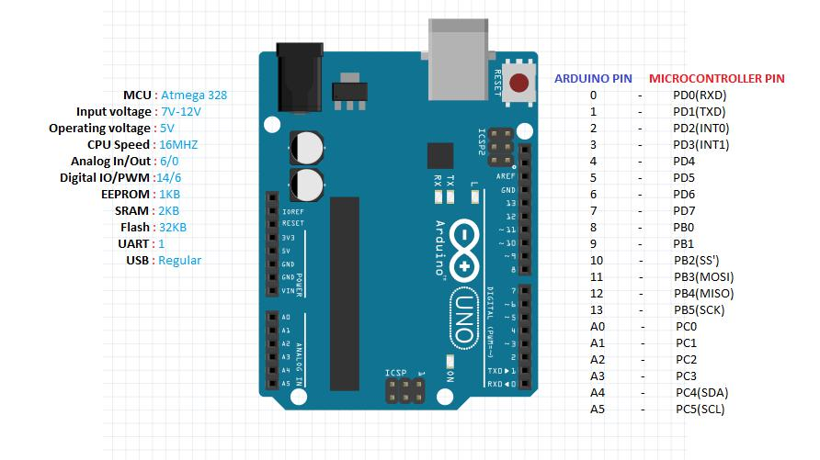 **ARDUINO UNO R3**

**Figure 3.1: Arduino UNO R3 pin diagram**

**Table 3.1 Pin configuration of Arduino Uno**

|  |  |
| --- | --- |
| Pin 0 to Pin 13 | DIGITAL MODE PINS |
| Pin A0 to Pin A5 | ANALOG MODE PINS |
| Pin 0 | Tx Pin |
| Pin 1 | Rx Pin |

**ARDUINO NANO**

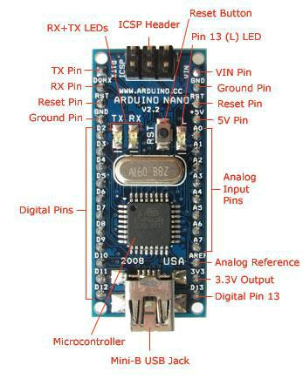

**Figure 3.2 Arduino Nano Pin Diagram**

**Table 3.2 Pin configuration of Arduino Nano**

|  |  |
| --- | --- |
| Pin D2 to pin D12 | DIGITAL MODE PINS |
| Pin A0 to Pin A7 | ANALOG MODE PINS |
| GND , RST Pin | GROUND AND RESET PIN |
| AREF | ANALOG REFERENCE |

**ARDUINO MEGA 2560**

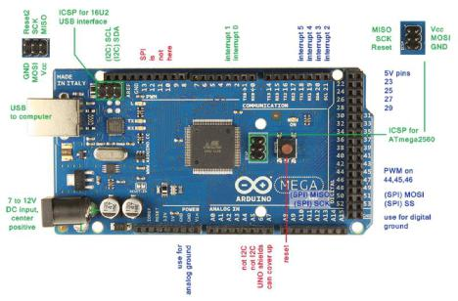

**Figure 3.3 Arduino Mega 2560 Pin diagram**

**Table 3.3 Pin configuration of Arduino Mega 2560**

|  |  |
| --- | --- |
| Pin 0 to Pin 53 | DIGITAL MODE PINS |
| Pin A0 to Pin A15 | ANALOG MODE PINS |
| Pin 18 to Pin 21 | INTERRUPT PINS |
| Pins 23,25,27,29 | 5V PINS |

**3.2 GSM/GPRS MODEM (GLOBAL SYSTEM FOR MOBILE**

**COMMUNICATION/GENRAL PACKET RADIO SERVICE):**

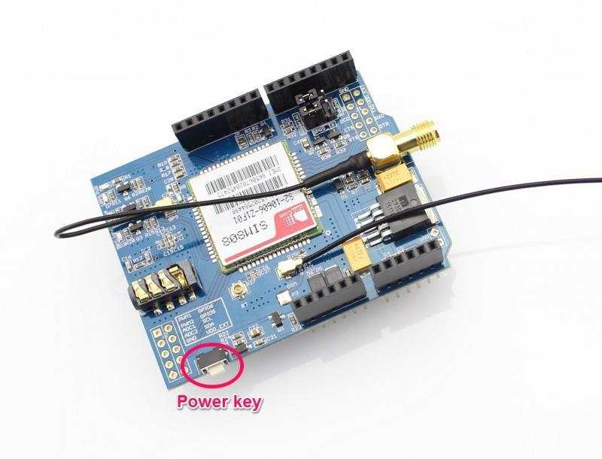

**Figure 3.4 GSM/GPRS SIM800A**

GSM/GPRS MODEM is a class of wireless MODEM devices that are designed for communication of a computer with the GSM and GPRS network. It requires a **SIM (Subscriber Identity Module)** card just like mobile phones to activate communication with the network. Also they have **IMEI** (International Mobile Equipment Identity) number similar to mobile phones for their identification. A GSM/GPRS MODEM can perform the following operations:

1. Receive, send or delete SMS messages in a SIM.
2. Read, add, search phonebook entries of the SIM.
3. Make, Receive, or reject a voice call.

The MODEM needs **AT commands**, for interacting with processor or controller, which are communicated through serial communication. These commands are sent by the controller/processor. The MODEM sends back a result after it receives a command. Different AT commands supported by the MODEM can be sent by the processor/controller/computer to interact with the **GSM and GPRS cellular network**.

A **GSM modem** is a specialized type of modem which accepts a SIM card, and operates over a subscription to a mobile operator, just like a mobile phone. From the mobile operator perspective, a GSM modem looks just like a mobile phone.

When a GSM modem is connected to a computer, this allows the computer to use the GSM modem to communicate over the mobile network. While these GSM modems are most frequently used to provide mobile internet connectivity, many of them can also be used for sending and receiving SMS and MMS messages.

A GSM modem can be a dedicated modem device with a serial, USB or Bluetooth connection, or it can be a mobile phone that provides GSM modem capabilities.

For the purpose of this document, the term GSM modem is used as a generic term to refer to any modem that supports one or more of the protocols in the GSM evolutionary family, including the 2.5G technologies GPRS and EDGE, as well as the 3G technologies WCDMA, UMTS, HSDPA and HSUPA.

GSM modems can be a quick and efficient way to get started with SMS, because a special subscription to an SMS service provider is not required. In most parts of the world, GSM modems are a cost effective solution for receiving SMS messages, because the sender is paying for the message delivery.

Due to some compatibility issues that can exist with mobile phones, using a dedicated GSM modem is usually preferable to a GSM mobile phone. This is more of an issue with MMS messaging, where if you wish to be able to receive inbound MMS messages with the gateway, the modem interface on most GSM phones will only allow you to send MMS messages. This is because the mobile phone automatically processes received MMS message notifications without forwarding them via the modem interface.

It should also be noted that not all phones support the modem interface for sending and receiving SMS messages. In particular, most smart phones, including Blackberries, iPhone, and Windows Mobile devices, do not support this GSM modem interface for sending and receiving SMS messages at all at all. Additionally, Nokia phones that use the S60 (Series 60) interface, which is Symbian based, only support sending SMS messages via the modem interface, and do not support receiving SMS via the modem interface.

**3.3 GPS (GLOBAL POSITIONING SYSTEM):**

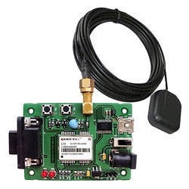

**Figure 3.5 GPS Module**

The **Global Positioning System** (**GPS**) shown in Fig 3.5 is a space-based radio navigation system owned by the United States government and operated by the United States Air Force. It is a [global navigation satellite system](https://en.wikipedia.org/wiki/Satellite_navigation) that provides [geolocation](https://en.wikipedia.org/wiki/Geolocation) and time information to a [GPS receiver](https://en.wikipedia.org/wiki/GPS_receiver) anywhere on or near the Earth where there is an unobstructed line of sight to four or more GPS satellites.

A GPS device can retrieve from the GPS system **location and time information** in all weather conditions, anywhere on or near the Earth. A GPS reception requires an unobstructed line of sight to four or more GPS satellites, and is subject to poor satellite signal conditions. In exceptionally poor signal conditions, for example in urban areas, satellite signals may exhibit multipath propagation where signals skip off structures, or are weakened by meteorological conditions. Obstructed lines of sight may arise from a tree canopy or inside a structure, such as in a building, garage or tunnel.

The GPS module continuously produces a set of data regarding the position of the earth surface where it is situated which includes the current position with respect to the equator of the earth in terms of Latitude and Longitude. This data can be decoded and printed into the readable format with the help of a microcontroller only. In this project the data regarding the geographical coordinate is extracted from the **GPS**output with the help of the **Arduino**. The Arduino can be used as a stand-alone board of which the output or inputs can be taken from the boards or given to the board. They can communicate using standard communication ports like USART, TWI, SPI etc. which enables them to be connected with various kinds of devices. The Arduino board is designed for easy prototyping and the IDE used for coding is very simple and provides so many libraries for interfacing with common external devices.

Using the function **Serial.read()** the Arduino continuously reads the data from the GPS module, looking for Latitude-Longitude details. The GPS send the data in standard NMEA format which consist of the real time data regarding the current position. The format includes so many sentences and among them one particular sentence referred to as “Global Positioning System Fix Data” is extracted to read the Latitude Longitude.

**Example:**

$GPRMC,092204.999,A,4250.5589,S,14718.5084,E,0.00,89.68,211200,,*25**`**

**Table 3.4 Sample GPS Data and Sentence Format**

|  |  |  |
| --- | --- | --- |
| **Field** | **Example** | **Comments** |
| Sentence ID | $GPRMC |  |
| UTC Time | 092204.999 | hhmmss.sss |
| Status | A | A = Valid, V = Invalid |
| Latitude | 4250.5589 | ddmm.mmmm |
| N/S Indicator | S | N = North, S = South |
| Longitude | 14718.5084 | dddmm.mmmm |
| E/W Indicator | E | E = East, W = West |
| Speed over ground | 0.00 | Knots |
| Course over ground | 0.00 | Degrees |
| UTC Date | 211200 | DDMMYY |
| Magnetic variation |  | Degrees |
| Magnetic variation |  | E = East, W = West |
| Checksum | *25 |  |

**3.4 12V DC MOTOR:**

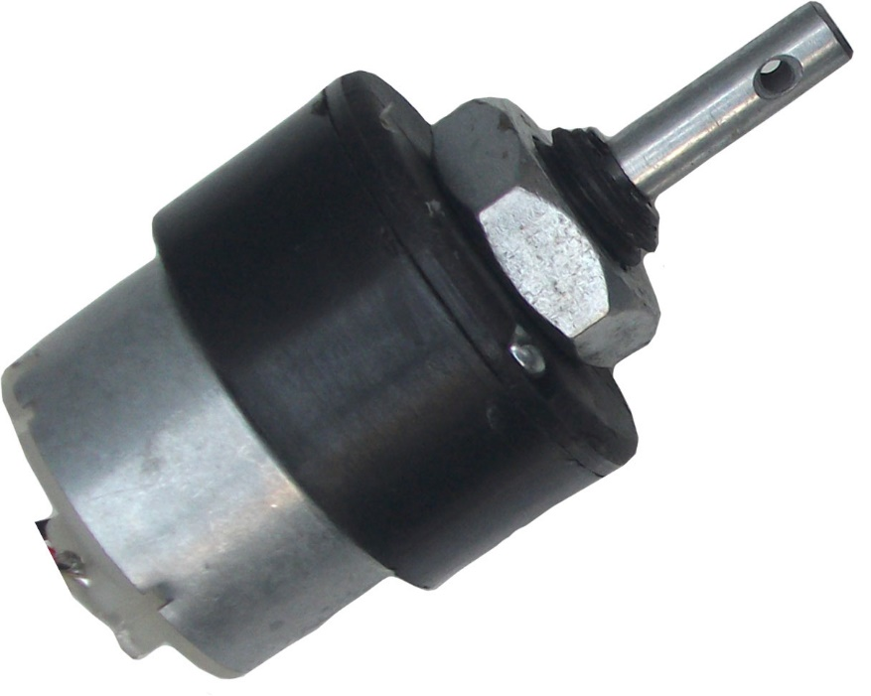

**Fig 3.6 12V DC Motor**

A **DC motor** (Fig 3.6) is any of a class of rotary electrical machines that converts direct current electrical energy into mechanical energy. The most common types rely on the forces produced by magnetic fields. Nearly all types of DC motors have some internal mechanism, either electromechanical or electronic, to periodically change the direction of current flow in part of the motor.

Here, the **DC motor** is used to emulate the motorcycle engine. The **Motorcycle engine** is similar to the DC motor. A motorcycle engine is an engine that powers a motorcycle. Motorcycle engines are typically two-stroke or four-stroke internal combustion engines, but other engine types (such as Wankels and electric motors) have been used in small numbers.

It is a variable speed motor. The speed is low at high Page on torque at light or no load, the motor speed attains dangerously high speed. The motor has a high starting torque.

**3.5 5V VOLTAGE REGULATOR (KA7805):**

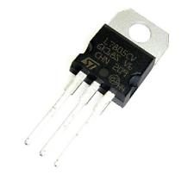 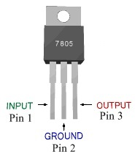

**Fig 3.7 Regulator module Fig 3.8 Pin Diagram of 7805**

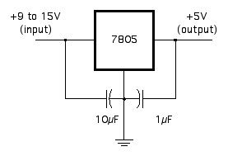

**Fig 3.9 Circuit Connection of 7805**

**7805** shown in Fig 3.7 is a voltage regulator integrated circuit. It is a member of 78xx series of fixed linear voltage regulator ICs. The voltage source in a circuit may have fluctuations and would not give the fixed voltage output. The voltage regulator IC maintains the output voltage at a constant value. The xx in 78xx indicates the fixed output voltage it is designed to provide. 7805 provides +5V regulated power supply. Capacitors of suitable values can be connected at input and output pins depending upon the respective voltage levels.

**Table 3.5 Pin Description of 7805**

|  |  |  |
| --- | --- | --- |
| **Pin No** | **Function** | **Name** |
| 1 | Input voltage (5V-18V) | Input |
| 2 | Ground (0V) | Ground |
| 3 | Regulated output; 5V (4.8V-5.2V) | Output |

A regulated power supply is very much essential for several electronic devices due to the semiconductor material employed in them have a fixed rate of current as well as voltage. The device may get damaged if there is any deviation from the fixed rate. The AC power supply gets converted into constant DC by this circuit. By the help of a voltage regulator DC, unregulated output will be fixed to a constant voltage. The circuit is made up of linear voltage regulator 7805 along with capacitors and resistors with bridge rectifier made up from diodes. From giving an unchanging voltage supply to building confident that output reaches uninterrupted to the appliance, the diodes along with capacitors handle elevated efficient signal conveyal.

**3.6 MOTOR BIKE IGNITION LOCK:**

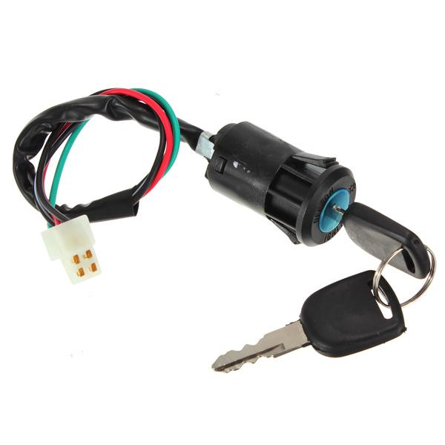

**Fig 3.10 Motor Bike Ignition Lock**

An **ignition lock** or **starter switch** shown in Fig 3.10 is a switch in the control system of an internal combustion engine motor vehicle that activates the main electrical systems for the vehicle. Besides providing power to the starter solenoid and the ignition system components (including the engine control unit and ignition coil) it also usually switches on power to many "accessories" (radio, power windows, etc.). The ignition switch usually requires a key be inserted that works a lock built into the switch mechanism. It is frequently combined with the starter switch which activates the starter motor. The ignition locking system may be bypassed by disconnecting the wiring to the switch and manipulating it directly; this is known as **hotwiring**.

The [ignition system](https://en.wikipedia.org/wiki/Ignition_system) is used to ignite the fuel-air mixture in the engine. The starter system is the ignition system, plus the [battery](https://en.wikipedia.org/wiki/Automotive_battery), and starter switch and DC [starter motor](https://en.wikipedia.org/wiki/Starter_motor). The ignition lock is key component for all the systems.

**SYSTEM DESIGN**

**CHAPTER 4**

**4 SYSTEM DESIGN**

This chapter will provide the system flow diagram and also explain the design of the various modules of the parking system. This system consists of some major phases which are described below.

**4.1 INTRODUCTION**

A sequence of modules are used in the system design. Each object embedded with Arduino Uno R3 board, GSM/GPRS sim800A modem, GPS module, 5V Relay and 5V Regulator (KA7805).

Programs can be loaded on to it from the easy-to-use Arduino computer program. The Arduino has an extensive support community, which makes it a very easy way to get started working with embedded electronics.

The Arduino can "talk", (transmit or receive data data) via a serial channel, so any other device with serial capabilities can communicate with an Arduino. It doesn't matter what program/programming language is driving the other device.

Serial is used for communication between the Arduino board and a computer or other devices. All Arduino boards have at least one serial port (also known as a UART or USART): **Serial**. It communicates on digital pins 0 (RX) and 1 (TX) as well as with the computer via USB. Thus, if you use these functions, you cannot also use pins 0 and 1 for digital input or output.

There is also an Arduino environment's built-in serial monitor to communicate with an Arduino board. Click the serial monitor button in the toolbar and select the same baud rate used in the call to begin ().

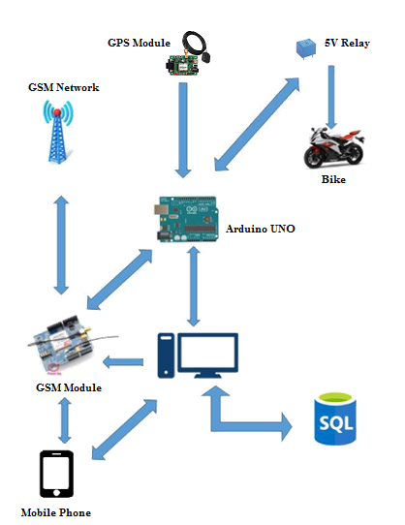

**Fig 4.1 Graphical View of the Bike Theft Detection System**

GSM modem depends on the service provider network. Only when the signal strength is excellent user can able to call and text. Arduino plays a vital role in this system. GSM, GPS, DC Motor through relay and Ignition Lock are serially connected to Arduino. PC communicates with Arduino through USB serial port. The GPS module fetches the current location data and send it to Arduino. The data from the Arduino is send to user mobile when the request are made. Only when bike is started without the key, the message is send to user automatically through GSM. User also can manually turn off the bike through SMS from his/her own mobile.

**4.2 FLOW CHART DIAGRAM**

**4.3 USE CASE DIAGRAM**

**4.4 DATABASE DESIGN**

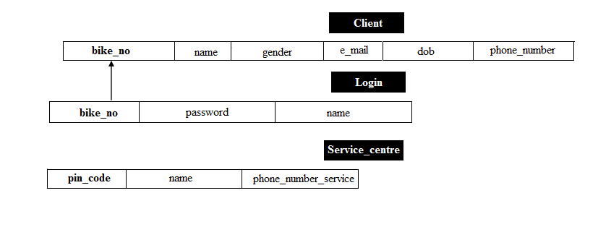

PRIMARY KEY: Client (bike_no), Service_centre(pin_code)

UNIQUE KEY: Service_centre(phone_number_service)

FOREIGN KEY: Login(bike_no)

**4.5 ARCHITECTURAL DIAGRAM**

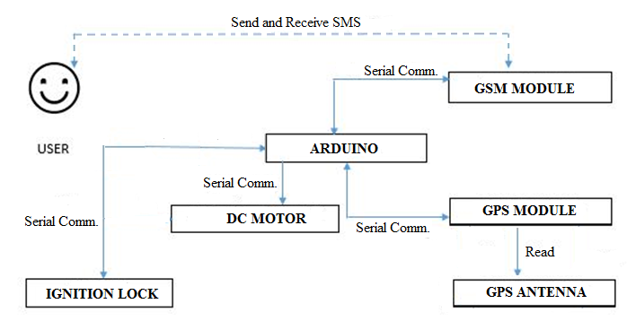

**Fig 4. Architecture Diagram**

The user can track and control by sending a SMS to the registered mobile number. The alert SMS are sent to owner mobile only when the certain action is triggered. The GSM is used only to receive and send SMS to the user. The GPS Receiver reads the data from Antenna and send back to Arduino through serial communication. The DC Motor and Ignition Lock are connected to Arduino through Relay circuit and Serial Communication. The Relay circuit is used to control the motor from microcontroller. Based on the user sent message certain actions are done by Arduino microcontroller.

**4.6 MODULES DESIGN**

* **LOCATION TRACKING AND ALERTING THE USER.**
* **CONTROLLING BIKE THROUGH GSM.**
* **NEAREST BIKE SERVICE LOCATION.**

**4.6.1 LOCATION TRACKING AND ALERTING THE USER:**

***Definition:***

This module is used for the observing of bike on the move and supplying a timely ordered sequence of respective location data from a system or model to users.

***Description:***

* The system uses **GPS Triangular Algorithm** for getting current position. The GPS antenna fetches data from three nearest satellites in the form of triangle. So, the algorithm is named as Triangular Algorithm.
* The GPS Outputs the Latitude and Longitude coordinates in NMEA Sentences.
* **GPGGA** and **GPRMC** sentences provide latitude and longitude of the current location. In this system GPRMC sentence is used for fetching data.
* The user can request for “Track Vehicle” option through SMS or Website after a valid authentication.
* **Way2SMS** gateway is used for sending message from website to GSM.
* The Current location Latitude and Longitude are send to owner or registered mobile number.
* The Google Map link for current location is also send to the registered mobile to view in map if the user has internet connection.

**4.6.2 CONTROLLING BIKE THROUGH GSM:**

***Definition:***

This module is used for the controlling of bike through messages from the user mobile phone or through internet.

***Description:***

* This module uses GSM, 5V Relay, 12V DC Motor and Ignition lock for controlling the bike.
* The Relay switch acts as vice versa to the Bike ignition lock. When bike is stated with the key, the relay is in OFF state. When bike is started without key the relay is in ON state.
* The motor runs when the specific key for that bike is used and the power supply is given.
* If motor is made to start without the key in ignition lock by removing the connection between motor and ignition lock, an alert SMS is sent to the registered mobile.
* On the recipient of alert message from system, the owner can reply with “Engine Off” SMS through his/her own mobile or through website after the valid authentication.
* The bike is turned off after the GSM receives the message and replied with current location of bike to the users.

**4.6.3 NEAREST BIKE SERVICE LOCATION:**

***Definition****:*

This module is used for determining the nearest bike service centre location through our website and able to send a message to the bike service centre for help.

***Description:***

* This module uses **navigator.geolocation** , **navigator.geolocation.getcurrentpos- -ition()** for getting current position of user or owner.
* The pincode of the current location is determined and searched for service centre in the server (database).
* The nearest service centre is determined and displayed on the screen with their mobile number.
* The website contains “SEND SMS” button to send the message to the required service station for help.

**4.7 ARDUINO IDE**

Arduino programs may be written in any programming language with a compiler that produces binary machine code. Atmel provides a development environment for their microcontrollers, AVR Studio and the newer Atmel Studio.

Arduino is an open-source hardware. The hardware reference designs are distributed under a Creative Commons Attribution Share-Alike 2.5 license and are available on the Arduino website. Layout and production files for some versions of the hardware are also available. The source code for the IDE is released under the GNU General Public License, version 2.

The Arduino project provides the Arduino integrated development environment (IDE), which is a cross-platform application written in the programming language Java. It originated from the IDE for the languages Processing and Wiring. It is designed to introduce programming to artists and other newcomers unfamiliar with software development.

It includes a code editor with features such as syntax highlighting, brace matching, and automatic indentation, and provides simple one-click mechanism to compile and load programs to an Arduino board. A program written with the IDE for Arduino is called a "sketch".

The Arduino IDE supports the languages C and C++ using special rules to organize code. The Arduino IDE supplies a software library called Wiring from the Wiring project, which provides many common input and output procedures. A typical Arduino C/C++ sketch consist of two functions that are compiled and linked with a program stub main () into an executable cyclic executive program:

**Setup ()**: a function that runs once at the start of a program and that can initialize settings.

**Loop ()**: a function called repeatedly until the board powers off.

A typical program for a beginning Arduino programmer blinks a light-emitting diode (LED) on and off. This program is usually loaded in the Arduino board by the manufacturer. In the Arduino environment, a user might write such a program as shown below.

#define LED_PIN 13

void setup() {

pinMode(LED_PIN, OUTPUT); // Enable pin 13 for digital output

}

void loop() {

digitalWrite(LED_PIN, HIGH); // Turn on the LED

delay(1000); // Wait one second (1000 milliseconds)

digitalWrite(LED_PIN, LOW); // Turn off the LED

delay(1000); // Wait one second

}

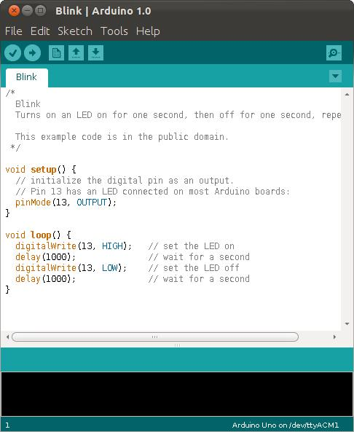

**Fig 4.4 A sample program running in Arduino IDE**

After compiling and linking with the GNU toolchain, also included with the IDE distribution, the Arduino IDE employs the program avrdude to convert the executable code into a text file in hexadecimal coding that is loaded into the Arduino board by a loader program in the board's firmware.

**SYSTEM IMPLEMENTATION**

**CHAPTER 5**

**5 SYSTEM IMPLEMENTATION**

A detailed Description of each of the different modules in the system design was provided in the previous chapter. As a continuation of that, this chapter will provide the information about the various functions deployed by our system and the corresponding implementation details pertaining to those functions.

**5.1 SIM900 GSM/GPRS MODEM – ARDUINO INTERFACING**

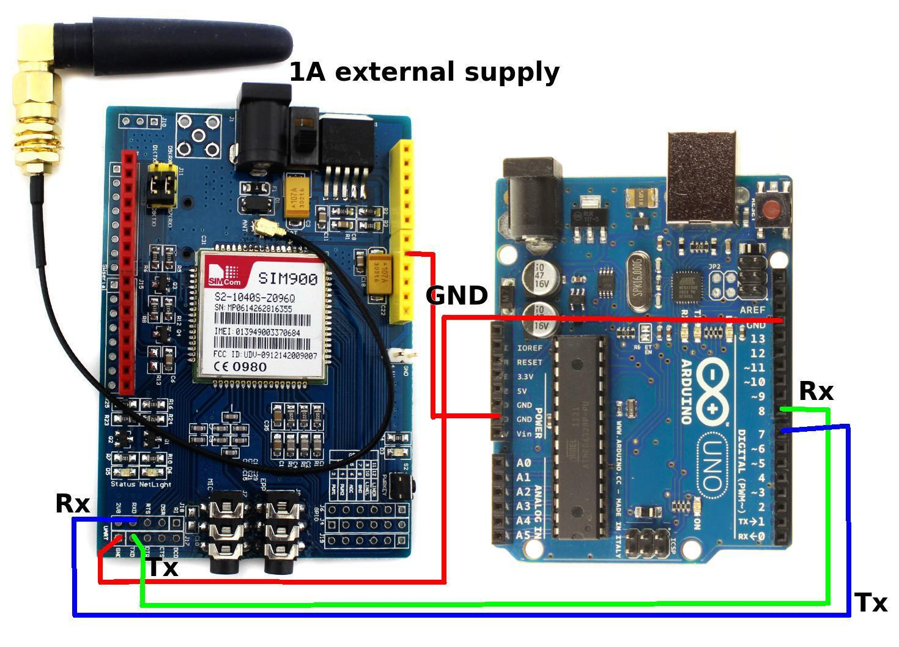

**Fig 5.1 Arduino-GSM interface**

**AT command used in GSM/GPRS Modem:**

AT commands-command used for SMS sending and receiving.

– AT-To check the modem

– AT+CMGF=1-To change to text mode

– AT+CMGS=“Mobile NO”- To send SMS to a new Number.

– AT+CMGR=”INDEX NO”- Read certain message

– AT+CNMI=2,0,0,0,0 – Receiving live messages.

– ATD “Mobile No” – Call to a number

– ATH – Hang a call

**Table 5.1: Arduino GSM Interfacing Pin Configuration**

|  |  |
| --- | --- |
| **GSM INTERFACING** | **ARDUINO INTERFACING** |
|  |  |
| Receiver Pin (Rx) | Transmitter Pin(Tx) Pin 0 |
|  |  |
| Transmitter Pin(Tx) | Receiver Pin (Rx) Pin 1 |
|  |  |
| GND | GND of Arduino. |
|  |  |
| Vcc | 5V of Arduino. |
|  |  |

**5.2 GPS MODULE-ARDUINO INTERFACING**

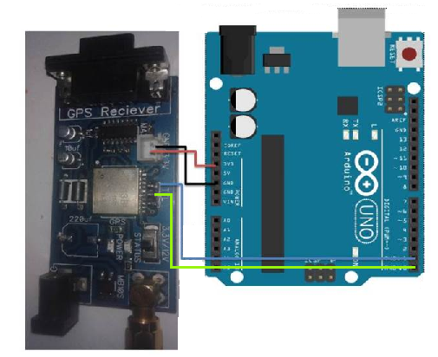

**Fig 5.2 GPS-Arduino Interface**

For interfacing GPS with computer we either need USB to Serial Converter or Arduino Board. Here we are using Arduino board to interface GPS as shown in Fig 5.2.

We only need **Arduino Board, GPS module** and 12v/3.3v adaptor for power supply. Here we have used GPS receiver Module SKG13BL.

**Table 5.1: Arduino GPS Interfacing Pin Configuration**

|  |  |
| --- | --- |
| **GPS INTERFACING** | **ARDUINO INTERFACING** |
|  |  |
| Receiver Pin (Rx) | Transmitter Pin(Tx) Pin 0 |
|  |  |
| Transmitter Pin(Tx) | Receiver Pin (Rx) Pin 1 |
|  |  |
| GND | GND of Arduino. |
|  |  |
| Vcc | 5V of Arduino. |
|  |  |

After connections as per the instruction in Table 5.2, connect the USB cable to the computer, open your Arduino IDE software in computer, select com port and open serial monitor to listen the serial port and Power up the Arduino and GPS module.

Now you will see GPS data on Arduino Serial Monitor Window in below Fig 5.3 and Fig 5.4. Fig 5.3 is when GPS is not in range and Fig 5.4 is when GPS in range.

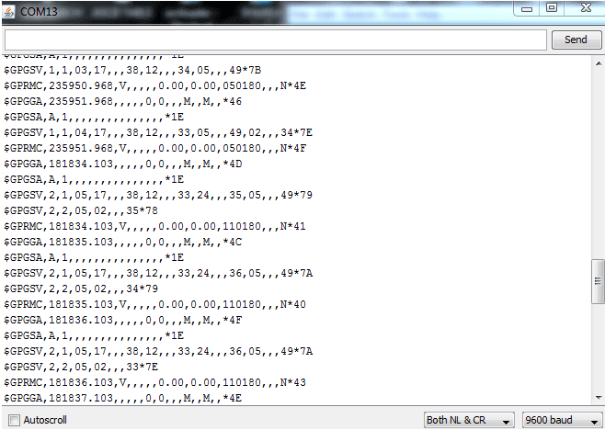

**Fig 5.3 Snapshot of Serial Monitor when GPS is not in range**

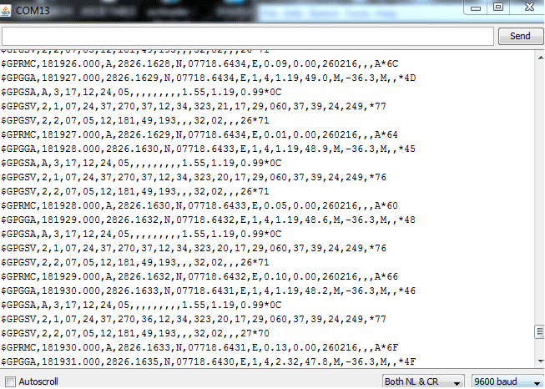

**Fig 5.3 Snapshot of Serial Monitor when GPS is in range**

In serial Window, you can see some sentences that start from $ sign. These are **NMEA sentences.** GPS module sends the Real time tracking position data in NMEA format (see the Fig 5.2 and Fig 5.3 above). NMEA format consist several sentences, in which four important sentences are given below.

* $GPGGA: Global Positioning System Fix Data
* $GPGSV: GPS satellites in view
* $GPGSA: GPS DOP and active satellites
* $GPRMC: Recommended minimum specific GPS/Transit data

These strings contain many GPS parameters like: Time, Date, Longitude, Latitude, speed, no. of satellites in used, altitude and many other things. For any location coordinates and time, we can use **$GPGGA and $GPRMC**. For Date and time we can use **$GPRMC** string.

**5.3 DC MOTOR-IGNITION LOCK-ARDUINO INTERFACING:**

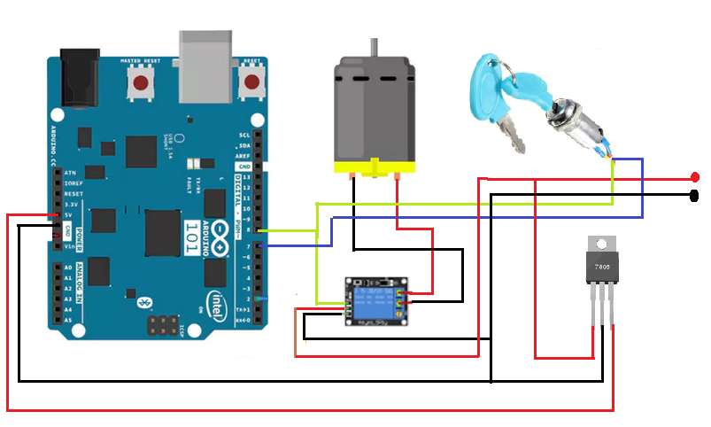

**Fig 5.4 DC Motor-Ignition Lock- Arduino Interface**

A DC motor (Direct Current motor) is the most common type of motor. DC motors normally have just two leads, one positive (red) and one negative (black). If you connect these two leads directly to a battery, the motor will rotate. If you switch the leads, the motor will rotate in the opposite direction.

The Voltage regulator (KA7805) is used to convert 12V supply to 5V. The Output(5V) from regulator is used by Arduino to power up. The Relay circuit is connected to DC motor through NC (Not Closed) and C (Closed) pin. The input for the relay is given by Ignition Lock and Arduino. The Output is send to Arduino for controlling the events.

The ignition lock acts similar to switch. The two connection from lock is taken and gives as input to the relay and Arduino. If ignition lock is turned ON the relay switch is closed and motor rotates. If it is turned OFF the relay switch is opened and connection is broken and the motor is stopped.

**RESULT AND DISCUSSION**

**CHAPTER 6**

**6 RESULTS AND DISCUSSION**

This chapter discusses about the results of different modules of the project.

**CONCLUSION   
AND FUTURE SCOPE**

**CHAPTER 7**

**7 CONCLUSION AND FUTURE SCOPE**

This chapter concludes the project report and provides possible scopes for various enhancements that can be made to this project in the future.

**7.1 CONCLUSION:**

Bike Theft Detection System is used to detect and control bike thefts via missed call and SMS. It is difficult to park the bike safe in an unknown place hence this system provides some safety features to surveillance the bike. This system reduces the manual security work and necessary of surveillance cameras in every places. In this system SMS plays a main role. When the thief tries to steal the bike by turning on the ignition without the key, the user gets a missed call and an alert sms to notify that his bike has been started. By sending a reply message he can turn off the ignition of his bike. If the owner arrives to that parked place within that certain time he can easily found his bike. Whether the bike is simply stolen by not turning on the bike he can simply track the bike's location by using the GPS embedded in the system. Whenever he needs an emergency in bike repair he can use the provided website to inform the service station. The alert to that service station will be sent by the website by simply taking the current location of the user. Based on theft happens the system can be used an additional of service station can be found around the owners location.

**7.2 FUTURE SCOPE:**

* + Using Tilt control, when any unauthorized person tilts the handle bar the system will send an alert message to the owner by using than owner can easily identify his bike's theft progress.
  + Camera is implemented along the tach-o-meter so that whoever sits on the bike can be identified the theft control may become into thief identifier.
  + GPRS can be implemented for storing the summary of the bike's various locations in the web portal.

**APPENDIX A**

**APPENDIX A**

**SYSTEM REQUIREMENTS**

**HARDWARE REQUIREMENTS:**

|  |  |  |
| --- | --- | --- |
| **PROCESSOR** | **:** | Intel core i3 processor. |
| **HARD DISK** | **:** | 120 GB Hard Disk Space. |
| **RAM** | **:** | 2 GB. |

**SOFTWARE REQUIREMENTS:**

**LANGUAGE** **:** Arduino programming Language,

PHP.

|  |  |  |
| --- | --- | --- |
| **OPERATING SYSTEM** | **:** | Windows 10. |
| **IDE** | **:** | Arduino IDE. |

**APPENDIX B**

**APPENDIX B**

**SOURCE CODE**

**ARDUINO CODE**

int Gpsdata; // for incoming serial data

#include <SoftwareSerial.h>

SoftwareSerial gsmSerial (9, 10);

const int key = 7;

const int mtr = 8;

const int led = 13;

int count=0;

unsigned int finish =0; // indicate end of message

unsigned int pos_cnt=0; // position counter

unsigned int lat_cnt=0; // latitude data counter

unsigned int log_cnt=0; // longitude data counter

unsigned int flg =0; // GPS flag

unsigned int com_cnt=0; // comma counter

char lat [20]; // latitude array

char lg [20]; // longitude array

char dir1;

char dir2;

char a [10];

char b [11];

int i;

void Receive_GPS_Data ();

void alter ();

void sen ();

void setup ()

{

Serial.begin(9600);

gsmSerial.begin(9600);

delay (100);

pinMode (key, INPUT);

pinMode (mtr, INPUT);

gsmSerial.println("AT+CMGF=1"); //Sets the GSM Module in Text Mode

delay (1000); // Delay of 1000 milli seconds or 1 second

gsmSerial.println("AT+CNMI=2,2,0,0,0"); // AT Command to receive a live SMS

delay (1000);

}

void loop ()

{

if (gsmSerial.available()>0)

{

String s=gsmSerial.readString();

if (s. indexOf("off")! =-1)

{

digitalWrite (mtr, HIGH);

delay (1000);

gsmSerial.println("AT+CMGF=1"); //Sets the GSM Module in Text Mode

delay (1000); // Delay of 1000 milli seconds or 1 second

gsmSerial.println("AT+CMGS=\"+919942338801\"\r"); // Replace x with mobile number

delay (1000);

gsmSerial.println("Your bike is stopped”) ;// The SMS text you want to send

delay (100);

gsmSerial.println((char)26) ;// ASCII code of CTRL+Z

delay (1000);

Receive_GPS_Data ();

delay (1000);

alter ();

sen ();

}

if (s. indexOf("track")! =-1)

{

Receive_GPS_Data ();

delay (1000);

alter ();

sen ();

}

}

if(digitalRead(key)==HIGH && digitalRead(mtr)==LOW)

{

if(count==0)

{

gsmSerial.println("AT+CMGF=1"); //Sets the GSM Module in Text Mode

delay (1000); // Delay of 1000 milli seconds or 1 second

gsmSerial.println("AT+CMGS=\"+919942338801\"\r");// Replace x with mobile number

delay (1000);

gsmSerial.println("Engine is ON Send OFF to turn off the engine”);

// The SMS text you want to send

delay (100);

gsmSerial.println((char)26) ;// ASCII code of CTRL+Z

delay (1000);

count=1;

delay (100);

gsmSerial.println("AT+CNMI=2,2,0,0,0");

// AT Command to receive a live SMS

delay (100);

}

if(digitalRead(key)==HIGH && digitalRead(mtr)==HIGH)

count=0;

}

}

void Receive_GPS_Data ()

{

while(finish==0) {

while (Serial.available()>0) {// Check GPS data

Gpsdata = Serial.read();

flg = 1;

if (Gpsdata=='$' && pos_cnt == 0) // finding GPRMC header

pos_cnt=1;

if (Gpsdata=='G' && pos_cnt == 1)

pos_cnt=2;

if (Gpsdata=='P' && pos_cnt == 2)

pos_cnt=3;

if (Gpsdata=='R' && pos_cnt == 3)

pos_cnt=4;

if (Gpsdata=='M' && pos_cnt == 4)

pos_cnt=5;

if (Gpsdata=='C' && pos_cnt==5)

pos_cnt=6;

if (pos_cnt==6 && Gpsdata ==',’) {// count commas in message

com_cnt++;

flg=0;

}

if (com_cnt==3 && flg==1) {

lat[log_cnt++] = Gpsdata; // latitude

flg=0;

}

if (com_cnt==4 && flg ==1) {

dir1 = Gpsdata;

flg=0;

}

if (com_cnt==5 && flg==1) {

lg[log_cnt++] = Gpsdata; // Longitude

flg=0;

}

if (com_cnt==6 && flg ==1) {

dir2 = Gpsdata;

flg=0;

}

if (Gpsdata == '*' && com_cnt >= 6) {

com_cnt = 0; // end of GPRMC message

lat_cnt = 0;

log_cnt = 0;

flg = 0;

finish = 1;

}

}

}

}

void alter ()

{

for (i=0; i<10; i++)

{

a[i]=lat[i];

}

for (i=0; i<11; i++)

{

b[i]=lg[i];

}

a [2] ='.';

a [3] =lat [2];

a [4] =lat [3];

b [3] ='.';

b [4] =lg [3];

b [5] =lg [4];

Serial.print("Latitude: ");

Serial.print(a);

Serial.println(dir1);

Serial.print("Longitude: ");

Serial.print(b);

Serial.println(dir2);

finish = 0; pos_cnt = 0;

}

void sen ()

{

gsmSerial.println("AT+CMGF=1");

delay (100);

gsmSerial.println("AT+CMGS=\"+919942338801\"\r");

delay (100);

gsmSerial.println("Your bike location is");

delay (100);

gsmSerial.print("Lattitude: ");

delay (100);

gsmSerial.print(a);

delay (100);

gsmSerial.println(dir1);

delay (100);

gsmSerial.print("Longitude: ");

delay (100);

gsmSerial.print(b);

delay (100);

gsmSerial.println(dir2);

delay (100);

gsmSerial.print("http://maps.google.com/? q=<");

gsmSerial.print(a);

gsmSerial.print(">, <");

gsmSerial.print(b);

gsmSerial.print(">");

delay (100);

gsmSerial.println((char)26) ;//the ASCII code of the ctrl+z is 26

delay (100);

}

**Web Portal – https://safeexpress.000webhostapp.com**

**Homepage.php:**

<! DOCTYPE HTML>

<html>

<head>

<title>Safe Express</title>

<meta charset="utf-8" />

</head>

<body class="landing">

<! -- Header -->

<header id="header" class="alt" style="position: fixed; list-style-type: none; padding-bottom: 5; overflow: hidden; margin: 2; padding: 2; top: 0; bottom: 0; width: 100%; background-color: #415f5f;">

<h1><a href="index.php">Safe Express</a></h1>

<a href="#nav">Menu</a>

</header>

<p>

<! -- Nav -->

<nav id="nav">

<ul class="links">

<li><a href="index.php">Home</a></li>

<li><a href="login.php">Login</a></li>

<li><a href="feature.php">Features</a></li>

<li><a href="aboutus.php">About Us</a></li>

<li><a href="contact.php">Contact</a></li>

</ul>

</nav>

<! -- Banner -->

<section id="banner">

<div class="inner">

<header>

<h1 style="font: normal bold 250% Georgia, serif;">

SAFE EXPRESS</h1>

<p style="font: italic 120% Georgia, serif; text-transform: capitalize">

we Believe in keeping your Bike safe

<br />

</p>

</header>

</div>

</section>

<section id="one" class="wrapper style1">

<div class="inner">

<h1 style="font: normal bold 200% Georgia, serif; color: white; text-transform: capitalize">Who we are </h1>

</div>

<br/>

<br/>

<hr/>

</section>

<section id="one" class="wrapper style1">

<div class="inner">

<article class="feature left">

<span class="image"><img src="images/pic01.jpg" alt="" /></span>

<div class="content">

<h2>Secure</h2>

<p>Go ahead and live free knowing that we are securing you from the word “GO,” with red alerts in the form of SMS. </p>

<br>

</div>

</article>

<article class="feature right">

<span class="image"><img src="images/pic02.jpg" alt="" /></span>

<div class="content">

<h2>Track</h2>

<p>Instant tracking through intelligent technology products to track your vehicle and asset location THEN and THERE! </p>

</div>

</article>

<article class="feature left">

<span class="image"><img src="images/pic03.jpg" alt="" /></span>

<div class="content">

<h2>Control</h2>

<p>Take COMPLETE CONTROL of your life and belongings in all walks of your life, WHEREVER YOU ARE, at a single click! </p>

</div>

</article>

</div>

</section>

<! -- Footer -->

<footer id="footer">

<div class="inner">

<ul class="copyright">

<li>&copy; Safe Express Tracking System</li>

<li>Images: <a href="http://unsplash.com">Unsplash</a>. </li>

<li>Design: <a href="http://templated.co">TEMPLATED</a>. </li>

</ul>

</div>

</footer>

</body>

</html>

**UserHomepage.php:**

<! DOCTYPE HTML>

<html>

<head>

<title>Safe Express</title>

<meta charset="utf-8" />

</head>

<body class="landing">

<! -- Header -->

<header id="header" class="alt" style="position: fixed; list-style-type: none; padding-bottom: 5px; overflow: hidden; margin: 2; padding: 2; top: 0; bottom: 5; width: 100%; background-color: #415f5f;">

<h1><a href="index.php">Safe Express</a></h1>

<a href="#nav">Menu</a>

</header>

<p>

<! -- Nav -->

<nav id="nav">

<ul class="links">

<li><a href="homepage.php">Home</a></li>

<li><a href="profile.php">Profile</a></li>

<li><a href="changepwd.php">change Password</a></li>

<li><a href="feedback.php">Feedback</a></li>

<li><a href="logout.php">Logout</a></li>

</ul>

</nav>

<! -- Banner -->

<div style="background-color: #415f5f;">

<? php

session_start ();

if (! isset($_SESSION['name']))

{

header ('location: login.php');

}

else

{

$name=$_SESSION['name'];

$bike no=$_SESSION['name'];

$mph=$_SESSION['myph'];

}

?>

</div>

<br/>

<div class="user" style="font: italic 110% Georgia, serif; text-transform: capitalize; color: white; background-color: #415f5f;">

<div style="text-align: left; margin-left: 15px;">Last Login:

<? php echo date ("d M, Y H: i: s”) ;>

</div>

<div style="text-align: right; margin-right: 15px; float: right;">Welcome

<? php echo $name?>

</div>

</div>

<! -- One -->

<section class="wrapper style1">

<div class="inner">

<header class="align-center">

</header>

<div class="flex flex-2">

<div class="video col">

<a href="https://safeexpress.000webhostapp.com/switchoff.php">

<div class="image fit">

<img src="./images/p1.jpg" alt="" />

<div class="arrow">

</div>

</a>

</div>

<p class="caption">

Control My Bike

</p>

</div>

<div class="video col">

<a href="https://safeexpress.000webhostapp.com/locate. Php">

<div class="image fit">

<img src="./images/p2.jpg" alt="" />

<div class="arrow">

</div>

</a>

</div>

<p class="caption">

Get My Bike Location

</p>

</div>

<div class="video col">

<a href="test.php">

<div class="image fit">

<img src="./images/p4.png" alt="" />

<div class="arrow">

</div>

</a>

</div>

<p class="caption">

Get the nearest Service Centre

</p>

</div>

</div>

</div>

</section>

<! -- Footer -->

<footer id="footer">

<ul class="copyright">

<li>&copy; Safe Express Tracking System</li>

83

<li>Images: <a href="http://unsplash.com">Unsplash</a>. </li>

<li>Design: <a href="http://templated.co">TEMPLATED</a>. </li>

</ul>

</div>

</footer>

</body>

</html>

**Sms.php:**

<? php

session_start ();

if (! isset($_SESSION['name']))

{

header ('location: login.php');

}

else

{

$name=$_SESSION['name'];

$bike no=$_SESSION['uname'];

$myph=$_SESSION['myph'];

$address=$_SESSION['address'];

$ph=$_SESSION['phonenumber'];

$comp=$_SESSION['companyname'];

}

error_reporting(E_ALL);

ob_implicit_flush(true);

include_once "class.curl.php";

include_once "class.sms.php";

include_once "cprint.php";

$smsapp=new sms ();

$smsapp->setGateway('way2sms');

$myno="9994150682";

$p="siva239325";

$message="HELP...I am “. $name."(“. $bikeno."). I am at “. $address.”. Phone:”. $myph." Thank You.";

//cprint ("Logging in.\n");

$ret=$smsapp->login ($myno, $p);

if (! $ret) {

//cprint ("Error Logging in");

exit (1);

}

//print ("Logged in Successfully\n");

//print ("Sending SMS.\n");

$ret=$smsapp->send ($ph, $message);

if (! $ret) {

//print ("Error in sending message");

exit (1);

}

//print ("Message sent");

//header ('refresh:0; service. Php');

header("Location:https://safeexpress.000webhostapp.com/service.php? companyname=$comp&phonenumber=$ph&address=$address", true, 301);

echo '<script language="javascript">';

echo 'alert ("Message successfully sent")';

echo '</script>';

?>

**latitude-longitude.php:**

<! DOCTYPE html>

<html lang="en">

<head>

<meta charset="UTF-8">

<title>Locating. </title>

<script type="text/javascript">

// Set up global variable

var result;

var address;

var latitude, longitude;

function showPosition () {

// Store the element where the page displays the result

//result = document. getElementById("result");

// If geolocation is available, try to get the visitor's position

if (navigator. Geolocation) {

navigator. geolocation. getCurrentPosition (successCallback, errorCallback);

//alert ("Getting the position information...");

} else {

alert ("Sorry, your browser does not support HTML5 geolocation.");

}

};

// Define callback function for successful attempt

function successCallback(position) {

latitude = position. coords. latitude;

longitude = position. coords. longitude;

//alert ("Your current position is (" + "Latitude: " + latitude + ", " + "Longitude: " + longitude+ ")");

if (latitude! = "" && longitude! = "") {

window. location. Href = "https://safeexpress.000webhostapp.com/getAddress.php?latitude=" + latitude + "&longitude=" + longitude;

}

else {

exit ();

}

}

// Define callback function for failed attempt

function errorCallback(error) {

if (error. code == 1) {

alert ("You've decided not to share your position, but it's OK. We won't ask you again.");

} else if (error. code == 2) {

alert ("The network is down or the positioning service can't be reached.");

} else if (error. code == 3) {

alert ("The attempt timed out before it could get the location data.");

} else {

alert ("Geolocation failed due to unknown error.");

}

}

</script>

</head>

<body onload="javascript: showPosition ();">

</body>

</html>

**getAddress.php:**

<? php

$latitude=$_GET['latitude'];

$longitude=$_GET['longitude'];

function getAddress ($latitude, $longitude) {

if (! empty($latitude) &&! empty($longitude)) {

//Send request and receive json data by address

$geocodeFromLatLong = file_get_contents('http://maps.googleapis.com/maps/api/geocode/json? latlng= ‘. trim($latitude).',’. trim($longitude).'&sensor=false');

$output = json_decode($geocodeFromLatLong);

$status = $output->status;

//Get address from json data

$address = ($status=="OK")? $output->results [1]->formatted_address:'';

//Return address of the given latitude and longitude

if (! empty($address)) {

return $address;

} else {

return false;

}

} else {

return false;

}

}

$address = getAddress ($latitude, $longitude);

$address = $address? $address:'Not found';

//echo $address;

$pincode=getZipcode($address);

function getZipcode($address) {

if (! empty($address)) {

//Formatted address

$formattedAddr = str_replace (' ','+’, $address);

//Send request and receive json data by address

$geocodeFromAddr =

file_get_contents('http://maps.googleapis.com/maps/api/geocode/json? address= ‘. $formattedAddr. ‘sensor=true_or_false');

$output1 = json_decode($geocodeFromAddr);

//Get latitude and longitute from json data

$latitude = $output1->results[0]->geometry->location->lat;

$longitude = $output1->results[0]->geometry->location->lng;

//Send request and receive json data by latitude longitute

$geocodeFromLatlon = file_get_contents('http://maps.googleapis.com/maps/api/geocode/json? latlng= ‘. $latitude.',’. $longitude.'&sensor=true_or_false');

$output2 = json_decode($geocodeFromLatlon);

if (! empty($output2)) {

$addressComponents = $output2->results [0]->address_components;

foreach ($addressComponents as $addrComp) {

if($addrComp->types [0] == 'postal_code’) {

return $addrComp->long_name;

}

}

return false;

} else {

return false;

}

} else {

return false;

}

}

$link = mysqli_connect ("localhost", "id738821_safeexpress", "men269652", "id738821_server");

// Check connection

If ($link === false) {

die ("ERROR: Could not connect. " . mysqli_connect_error ());

}

// Attempt select query execution

$sql = "SELECT companyname, phonenumber FROM servicecentre WHERE pincode='$pincode'";

if ($result = mysqli_query ($link, $sql)) {

if(mysqli_num_rows($result) > 0) {

while ($row = mysqli_fetch_array($result)) {

$companyname=$row['companyname'];

$phonenumber=$row['phonenumber'];

}

echo $companyname;

echo $phonenumber;

//Close result set

mysqli_free_result($result);

} else {

echo "No records matching your query were found.";

}

} else {

echo "ERROR: Could not able to execute $sql. " . mysqli_error($link);

}

// Close connection

mysqli_close($link);

if ($companyname! ="" && $phonenumber! ="")

{

header("Location:https://safeexpress.000webhostapp.com/service.php? companyname=$companyname&phonenumber=$phonenumber&address=$address", true, 301);

exit ();

}

?>

**Logout.php**

<?php

session_start();

unset($_SESSION['userid']);

session_destroy();

header('Location: index.php');

?>

**APPENDIX C**

**APPENDIX C**

**REFERENCES**

**1. Vehicle Tracking System using GPS and Android OS**

“Amol Dhumal, Amol Naikoji, Yutika Patwa, Manali Shilimkar, Prof. M. K. Nighot”,

International Journal of Advanced Research in Computer Engineering & Technology (IJARCET) Volume 4 Issue 4, April 2015.

**2. Intelligent Anti-Theft and Tracking System for Automobiles**

“Montaser N. Ramadan, Mohammad A. Al-Khedher, Senior Member, IACSIT, and

Sharaf A. Al-Kheder”, International Journal of Machine Learning and Computing, Vol. 2, No. 1, February 2012.

**3. Next Generation Auto Theft Prevention and Tracking System for land Vehicles**

“Bavya R, Mohanamurali R”, ICICES2014 - S.A. Engineering College, Chennai, Tamil Nadu, India.

**4. Design & Development of a GSM Based Vehicle Theft Control System**

“B.G. Nagaraja, Ravi Rayappa, M Mahesh, Chandrasekhar M Patil, Dr. T.C. Manjunath”,

International Conference on Advanced Computer Control.

**5. Vehicle Tracking System using GPS and Android OS**

“Amol Dhumal, Amol Naikoji, Yutika Patwa, Manali Shilimkar, Prof. M. K. Nighot”,

International Journal of Advanced Research in Computer Engineering & Technology (IJARCET) Volume 4 Issue 4, April 2015.

**6. GPS based Advanced Vehicle Tracking and Vehicle Control System**

“Mashood Mukhtar”, Queen Mary, University of London, Mile End Rd, London.

I.J. Intelligent Systems and Applications, 2015, 03, 1-12 Published Online February

2015 in MECS.